**Sprint – 3**

|  |  |
| --- | --- |
| Date | 04 November 2022 |
| Team ID | PNT2022TMID32303 |
| Project Name | Estimate the crop yield using Data Analytics |

**Creating The Dashboard:**

* Login to IBM Cognos then in open menu click **New -> Dashboard .**

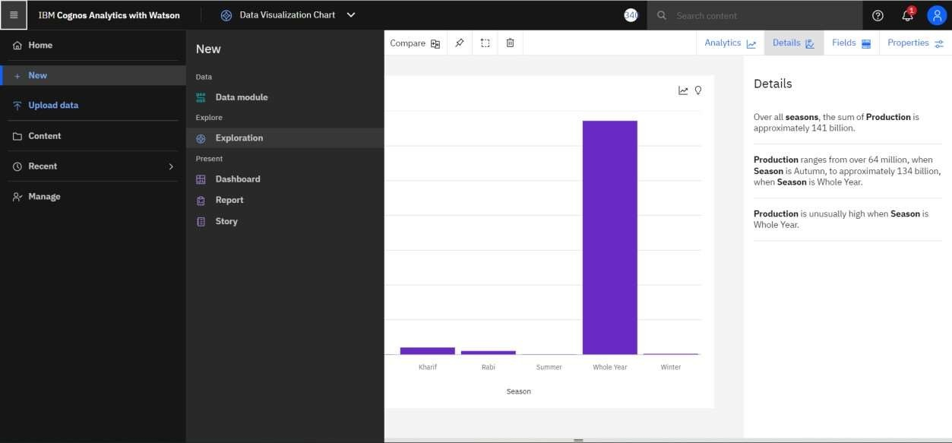

* Select a template for your dashboard and click create.

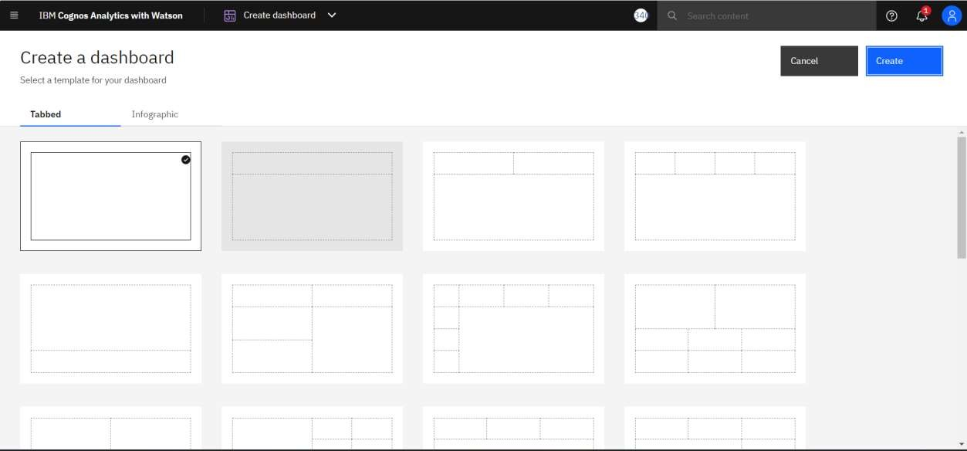

* Then select the **crop_production.csv** dataset under my content tab and click **add** In Add a source.

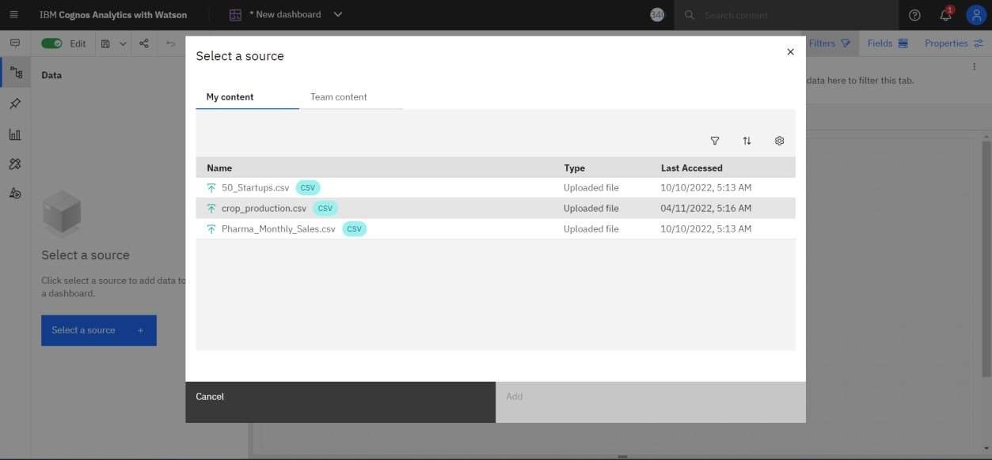

* Rename the tab title as Dashboard.
* Copy the Each visualization and paste it in the tab and arrange the chart.

